Session 10 -1

import java.util.Scanner;
import java.util.ArrayDeque;
import java.util.Deque;
import java.util.HashMap;
public class Solution {
public static void main(String[] args) {
Scanner in = new Scanner(System.in);
Deque<Integer> deque = new ArrayDeque<>();
HashMap<Integer, Integer> map = new HashMap<>();

int n = in.nextInt();
int m = in.nextInt();
int maxUnique = 0;
for (int i = 0; i < n; i++) {
int num = in.nextInt();

deque.addLast(num);
map.put(num, map.getOrDefault(num, 0) + 1);

if (deque.size() > m) {
int first = deque.removeFirst();
int count = map.get(first);
if (count == 1) {
map.remove(first);
} else {
map.put(first, count - 1);
}
}

if (deque.size() == m) {
maxUnique = Math.max(maxUnique, map.size());

if (maxUnique == m) {
break;
}
}
}

System.out.println(maxUnique);
in.close();
}
}

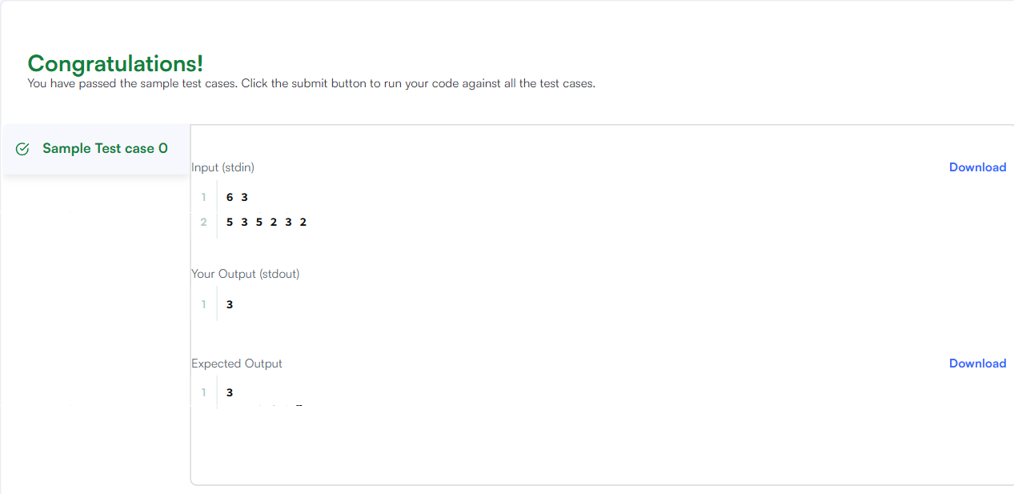

Seesion 10 -1
import java.util.Scanner;
import java.util.HashSet;

public class Solution {
public static void main(String[] args) {
Scanner s = new Scanner(System.in);
int t = s.nextInt();
String[] pair_left = new String[t];
String[] pair_right = new String[t];

for (int i = 0; i < t; i++) {
pair_left[i] = s.next();
pair_right[i] = s.next();
}

// Write your code here
HashSet<String> set = new HashSet<>();
for (int i = 0; i < t; i++) {
// Combine left and right strings with a space delimiter
set.add(pair_left[i] + " " + pair_right[i]);
// Print the current number of unique elements in the set
System.out.println(set.size());
}

s.close();
}
}

